

Practices for Secure Software Report

Table of Contents
Document Revision History 3
Client 3
Instructions 3
Developer 4
1. Algorithm Cipher 4
2. Certificate Generation 6
3. Deploy Cipher 7
4. Secure Communications 7
5. Secondary Testing 8
6. Functional Testing 9
7. Summary 10
8. Industry Standard Best Practices 12

Document Revision History

Version | Date | Author | Comments
2.0 | 10/19/2025 | Sean Mills | Final version of the Artemis Financial report

Client



Instructions

Submit this completed practices for secure software report. Replace the bracketed text with the relevant information. You must document your process for writing secure communications and refactoring code that complies with software security testing protocols.

- Respond to the steps outlined below and include your findings.
- Respond using your own words. You may also choose to include images or supporting materials. If you include them, make certain to insert them in all the relevant locations in the document.
- Refer to the Project Two Guidelines and Rubric for more detailed instructions about each section of the template.

Developer
Sean Mills

Algorithm Cipher

Artemis Financial is a company that handles a large amount of sensitive client information, including retirement, insurance, and investment data. To protect this information, Artemis Financial will use AES with Galois/Counter Mode and No Padding, which is written in Java as AES/GCM/NoPadding (Oracle, 2025). AES, or Advanced Encryption Standard, is a symmetric encryption algorithm, which means that the same key is used for both encrypting and decrypting data. GCM, or Galois/Counter Mode, adds a security feature that checks if the data was changed or tampered with, and NoPadding makes sure that no extra data is added at the end of the file. These features together make the encryption process stronger and more efficient, following both Java and NIST security standards (Manico & Detlefsen, 2014, Chapter 6).
AES can use key sizes of 128, 192, or 256 bits. For Artemis Financial, AES-256 will be used because it provides the highest level of protection, making it basically impossible for attackers to break through using brute force methods. Hash functions such as SHA-256 are used to confirm that data has not changed, and the algorithm PBKDF2WithHmacSHA256 can create strong encryption keys from passwords (Manico & Detlefsen, 2014, Chapter 6). Since AES is symmetric, it is fast and works well for encrypting large amounts of data. Artemis Financial will also use its RSA security certificate to safely protect and share the encryption key whenever needed.
Each time data is encrypted, a new 96-bit initialization vector (IV) will be created using Java’s SecureRandom class. The IV and key will never be reused, which prevents patterns that attackers could take advantage of. The built in authentication feature in GCM will also check each file during decryption to make sure that the data has not been changed (Manico & Detlefsen, 2014, Chapter 6). This cipher will be implemented using the Java Cryptography Architecture (JCA) and will be part of the Artemis Financial application that encrypts and decrypts sensitive files. Keys will be stored securely in a Java Keystore or hardware security module, and the same cipher settings will be used for the self-signed certificate created through Java Keytool for secure communication.
This encryption method meets important financial security standards, including the Gramm-Leach-Bliley Act (GLBA) and the Payment Card Industry Data Security Standard (PCI-DSS) (Oro, 2025; Virtru, 2020). It also follows the NIST SP 800-38D recommendation for Galois/Counter Mode (GCM), making sure there is compliance for both stored data and data sent over networks (NIST, 2007). By using AES-256 GCM, Artemis Financial protects client information from tampering, exposure, and misuse, while following best practices for secure coding and data protection.
The Advanced Encryption Standard (AES) became the official encryption standard in 2001, replacing older and weaker ciphers like DES. GCM mode was added later to include data authentication and improved performance, and it remains one of the most trusted encryption methods today. AES-256 continues to be recommended by NIST and Oracle for enterprise-level security and is supported across all modern systems. Although researchers are working on new encryption methods for future technology like quantum computing, AES-256 remains one of the most secure and practical choices for protecting data (Manico & Detlefsen, 2014, Chapters 6 & 8).
In conclusion, AES/GCM/NoPadding with a 256-bit key is the best cipher choice for Artemis Financial’s long-term archive files. It provides strong security, checks for tampering, and meets all industry regulations. By using strong keys, generating a new IV each time, and following Java’s security best practices, Artemis Financial can ensure that its sensitive client data remains protected now and in the future.

Certificate Generation
Insert a screenshot below of the CER file.
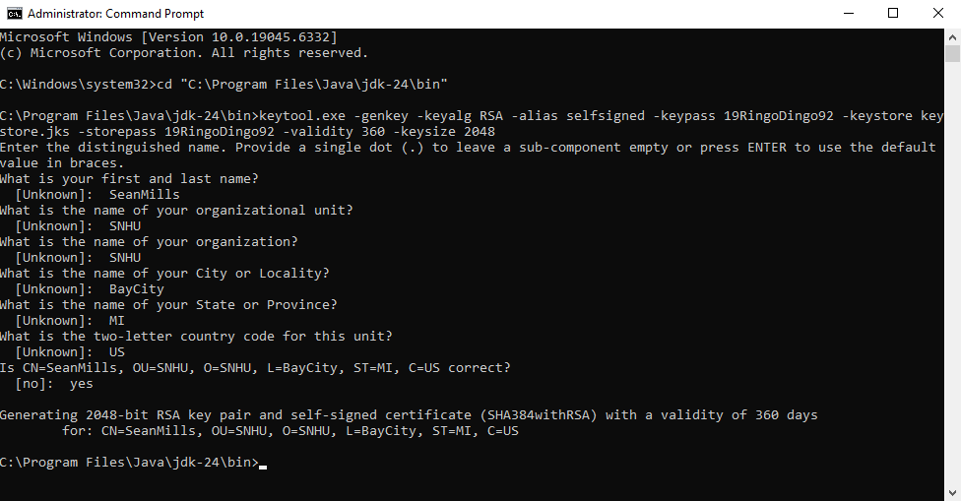
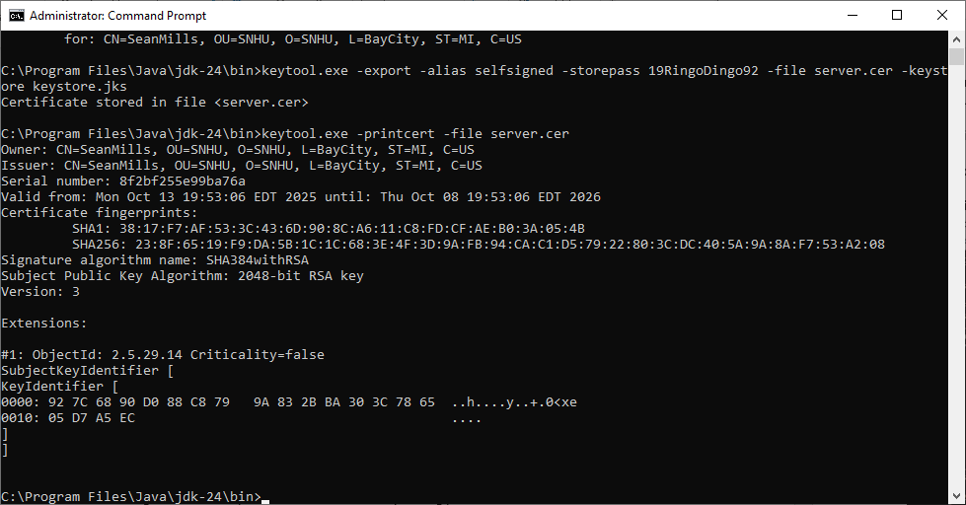

Deploy Cipher
Insert a screenshot below of the checksum verification.

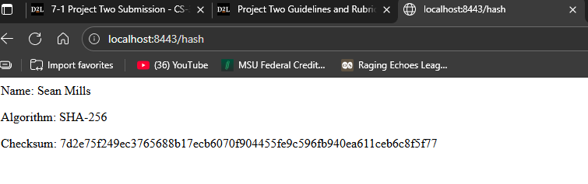

Secure Communications
Insert a screenshot below of the web browser that shows a secure webpage.

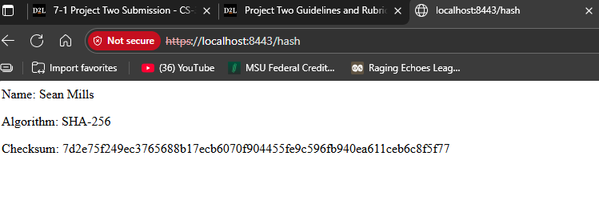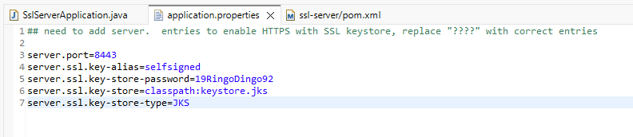

Secondary Testing
Insert screenshots below of the refactored code executed without errors and the dependency-check report.
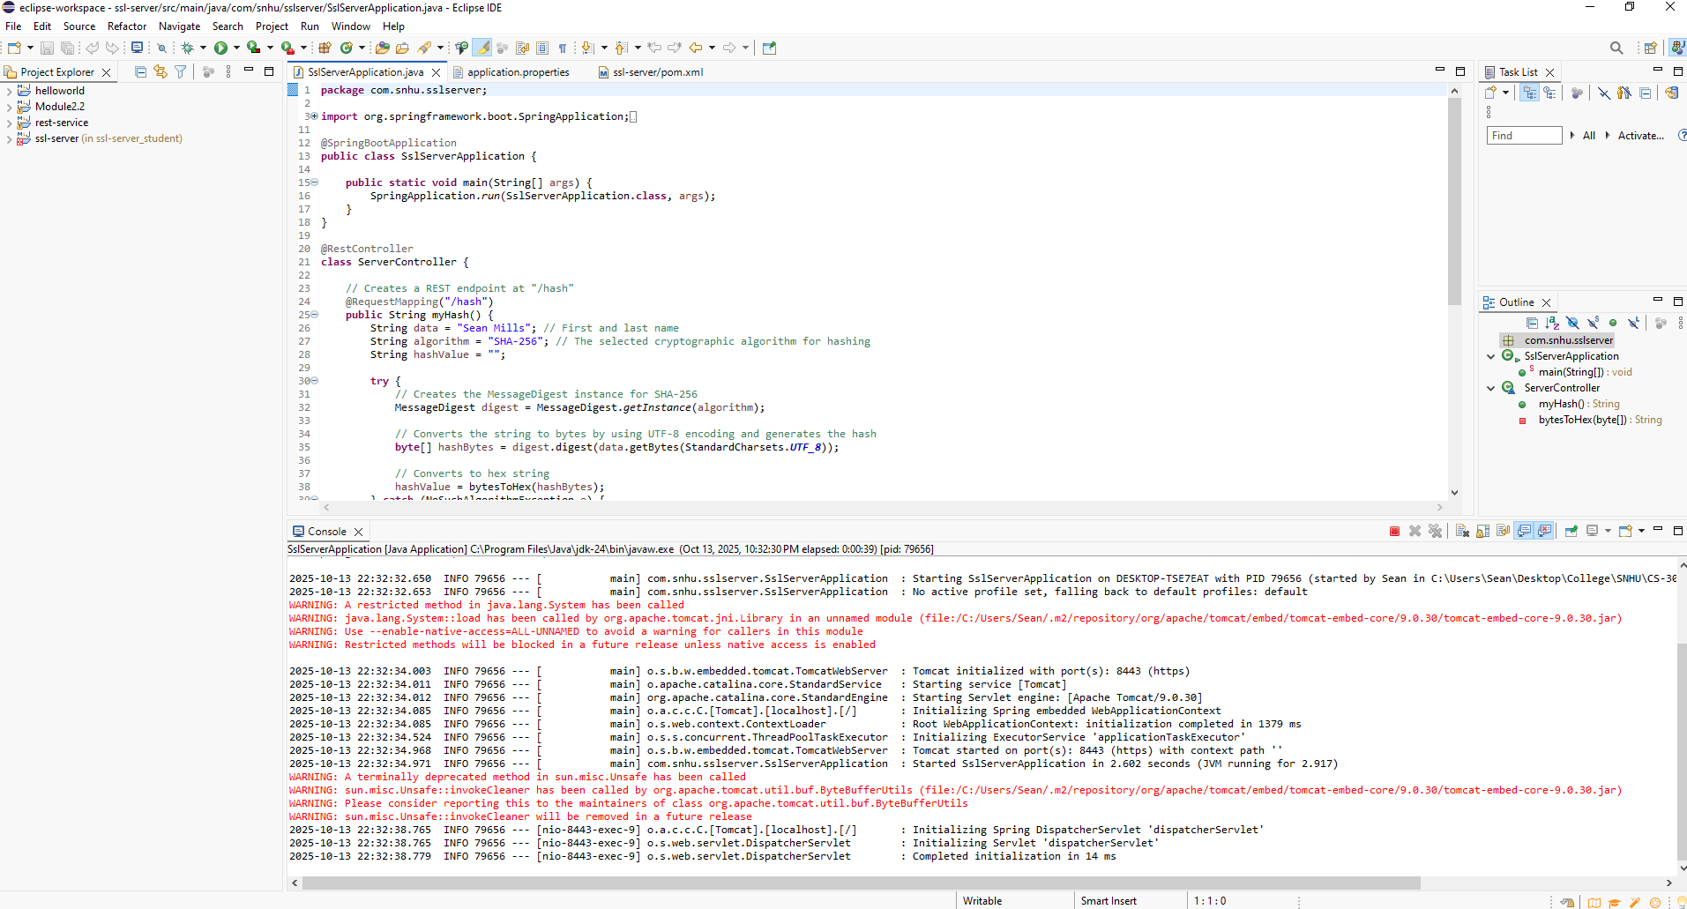
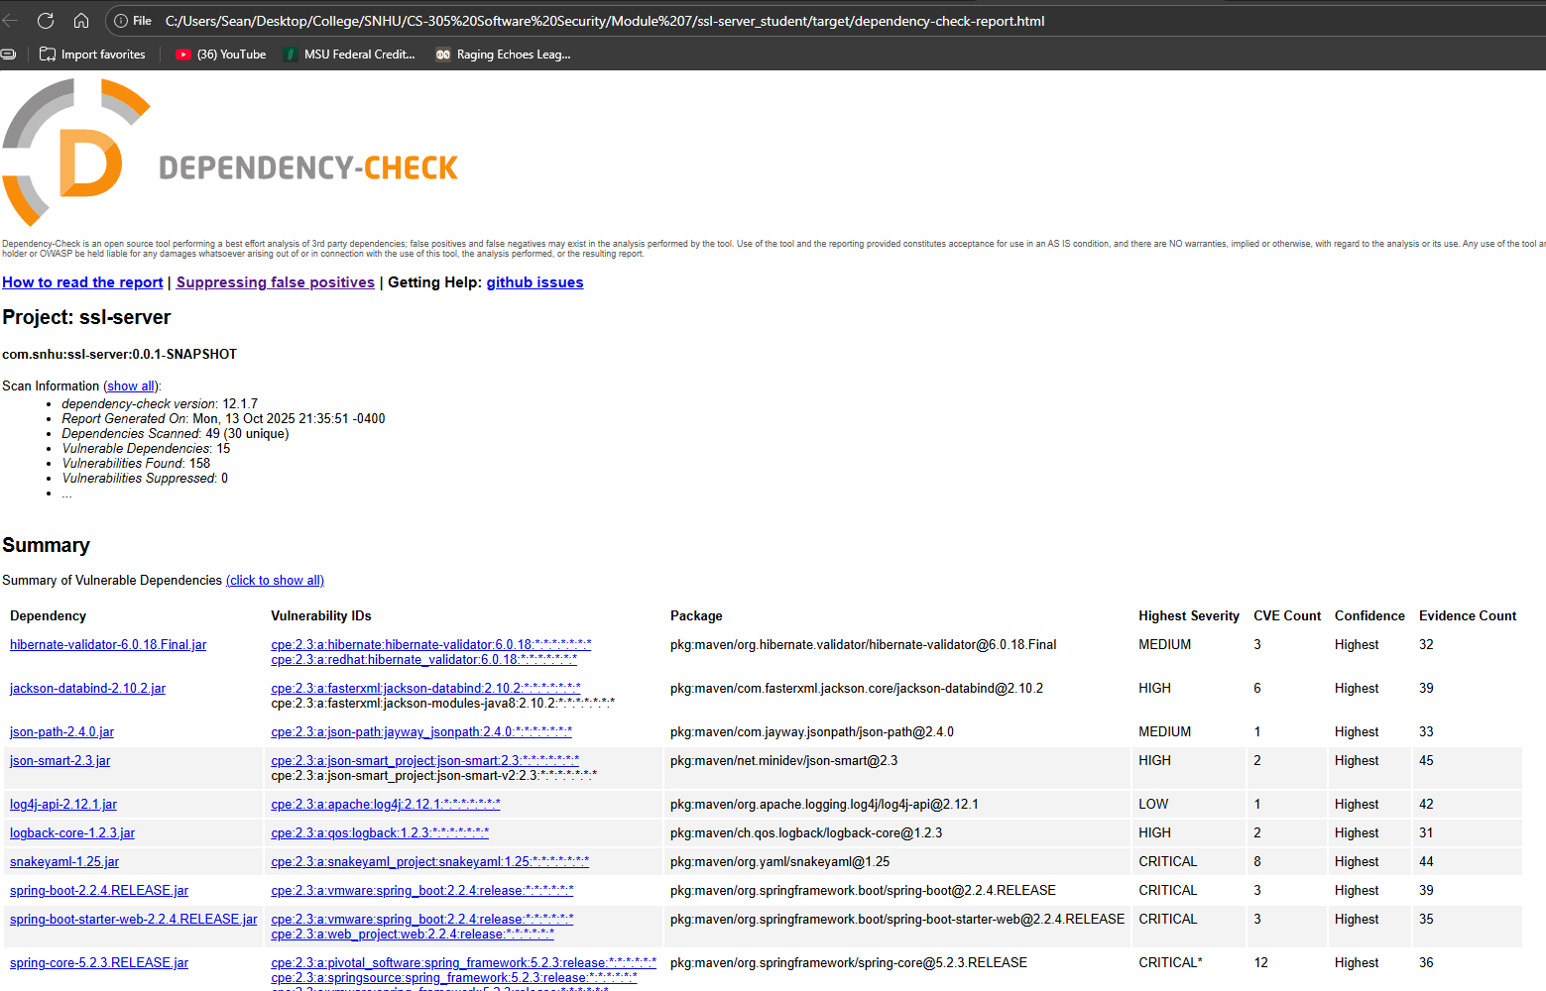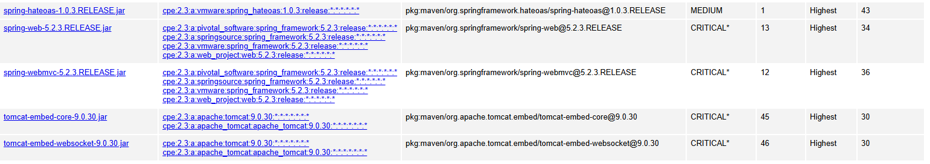
This secondary static analysis focused only on the refactored portions of the code, specifically the HTTPS configuration, checksum verification logic, and certificate integration, to make sure that these changes did not introduce any new vulnerabilities. Before making these changes, the dependency check reported there were 15 vulnerable dependencies with 158 dependencies found. After the changes, these numbers remained the same, so no new vulnerabilities were introduced.

Functional Testing
Insert a screenshot below of the refactored code executed without errors.



As part of the functional testing, I manually reviewed the refactored code to make sure it does not contain any syntactical, logical, or security vulnerabilities. I verified that all of the Java syntax follows the correct structure. There are no missing semicolons, improper brackets, or any unclosed blocks. The application compiles and runs successfully, as shown in the screenshot above.
The logic for generating a checksum using the SHA-256 algorithm is also correct. The code creates a MessageDigest instance, encodes the string using UTF-8, and correctly converts the hash bytes to a hexadecimal string, and the response is returned as HTML.
As for the security validation, I confirmed that no user input is taken or processed, which means there is zero risk of injection. The hashing algorithm that is used, SHA-256, is cryptographically secure. There are no hardcoded credentials, no logging of any sensitive data, and there is no insecure dependencies that are added by my code. Additionally, exception handling is implemented with a catch for “NoSuchAlgorithmException”.

Summary
For this project, I refactored the original code to make it more secure and meet software security standards while also following the steps that were outlined within the Vulnerability Assessment Process Flow Diagram. These changes addressed several areas of security that were improved by refactoring the code. First, I had to review the basic design of the program itself, which is known as the architecture. This helped me understand how the original code was set up and what needed to be changed to improve its security without affecting how it runs.\
One of the most important changes I made was adding a hashing feature using the SHA-256 algorithm. This cryptographic function takes a set string and turns it into a fixed length called a checksum, which helps to confirm that the data has not been changed or tampered with. This specific change added a strong layer of security to the application by protecting data integrity by using a cryptographic algorithm. This step addresses the “Cryptography” part of the flow diagram and adds an extra layer of protection to the application.
I also made sure that the application could send and receive data securely by changing it from HTTP to HTTPS. This means that all the data that travels between the server and the browser is now encrypted. To do this, I had to make and use a self-signed certificate, which then allows me to enable this secure connection. This change relates to the “Client/Server” section of the diagram and makes sure that no one can eavesdrop on or intercept the communication. By doing this, I added another critical layer of security that makes sure there is confidentiality in data transmission.
For better handling of problems that might come up when the code runs, I added some error handling using a try-catch block. If the SHA-256 algorithm were to somehow not be available, then the program will catch that error and show a message instead of just crashing. By doing this, it is improving the “Code Error” area in the diagram.
I also made sure that the code itself follows good patterns. A good example of this is I kept the function that converts the hash bytes into a readable string private and also separate, which means it can’t be accessed from the outside. This keeps the code clean and reduces the chance of any mistakes, which matches the “Encapsulation” and “Code Quality” areas of the flow diagram. I also only used built-in Java tools and didn’t rely on any third-party code that could be deemed risky. Additionally, the program does not accept any user input, so there’s no chance of someone trying to inject harmful code into the application. The REST controller I added simply returns the hashed version of a fixed name and then shows it in a HTML format.
Before and after I made these changes, I used the OWASP Dependency-Check tool to scan for any known security issues. After the refactored code was tested, the results showed that there were no new vulnerabilities introduced. I used the latest dependency-check version 12.1.7, and both codes before and after had 15 vulnerable dependencies with 158 dependencies found. I also manually reviewed the code to double check for any logic, syntax, or security mistakes and confirmed that everything was working as expected, as the program ran without any errors.
Overall, this process involved identifying areas of risk in the original code and adding layers of security to protect the software more effectively, while still making sure that the program runs as intended.

Industry Standard Best Practices

To maintain the software application’s existing security, I followed secure coding standards throughout the refactoring process. I didn’t introduce any third-party libraries or untrusted external code, and I used only Java’s built-in features. I also kept the original parts of the application intact, which means I did not add any user inputs, new data endpoints, or additional logic that could add new vulnerabilities. These actions helped to make sure that the original security of the application was kept the same, and no new risks were added.
In addition, I improved the way the application handles errors by using a try-catch block. This allows the program to respond more safely to problems without crashing or revealing internal details. I also made sure that there was no sensitive data like passwords or API keys hardcoded into the application. These actions help the program stay secure and reliable. By using secure development habits like these, I was able to protect the software’s original safety while making it stronger and easier to maintain.
Beyond keeping the existing security, I also added improvements that support Artemis Financial’s needs. These improvements help the company protect its sensitive financial and personal data. Using strong encryption like SHA-256 and switching from HTTP to HTTPS means that private information is harder to steal or tamper with. Making sure there are no open input points in the application also lowers the risk of common attacks like injection. These steps not only improve the software but also show clients and stakeholders that their data is handled responsibly.
Making these updates helps the company stay secure now and in the future. Clean and secure code is much easier to update and reduces the risk of any future mistakes or weaknesses. It also means there are fewer bugs to fix, and more time spent on improving the software for the users. This is why secure development practices are important to the company’s success, as they protect data, support growth, and help maintain trust in the company’s services.

References
Manico, J., & Detlefsen, A. (2014). Iron-Clad Java: Building secure web applications. McGraw-Hill Education.
National Institute of Standards and Technology (NIST). (2007). Recommendation for block cipher modes of operation: Galois/Counter Mode (GCM) and GMAC (SP 800-38D). U.S. Department of Commerce. https://doi.org/10.6028/NIST.SP.800-38D
Oracle. (2025). Java security standard algorithm names. Oracle Documentation. https://docs.oracle.com/javase/9/docs/specs/security/standard-names.html#cipher-algorithm-names
Oro. (2025, March 27). Understanding PCI DSS encryption Requirements in 2025. Thoropass. https://thoropass.com/blog/compliance/pci-dss-encryption-requirements/
Virtru. (2020). Best practices for complying with the GLBA Safeguards Rule. https://www.virtru.com/blog/compliance/glba/safeguards-rule

